IMPRESSIONISM ART MOVEMENT

Student’s Name
Course Title
Date

Today, modern art is a representation of embryonic set of ideas among various photographers, portraitists, authors, performers, as well as sculptors who collectively and single-handedly sought novel tactics to art-making. The imaginative world's rejoinder to the rationalist carry out besides viewpoints of new life as well as concepts offered by the advancement in technology of the industrial age that prompted present-day society to evident itself in new-fangled ways likened to the past is the basis of modern art. Though the term applies to numerous genera of art straddling more than a century, from artistic perspective, artist's commitment to depicting a subject as it occurs in the world based on personal inimitable viewpoint and epitomized by a denunciation of acknowledged otherwise conventional styles, as well as values, is what characterizes modern art.¹
The history of art as a subject has a tendency of categorizing individuals into sects of historical networks and similar-minded artists nominated as the distinct schools and movements. This unpretentious method of creating classes is specifically pertinent due to its application to centralized movements with a solitary purpose such as surrealism, impressionism and futurism. However, it is worth a note at this juncture that various schools rather movements of art comprise of extensively assorted means and artists of artistic depiction. Hence, the act of grouping artists into movements is not often entirely apposite or precise.² For instance, based on a consecutive place in antiquity as well as artists' resolve to deviate from impressionist motifs, a movement termed as post-impressionism was born. The chief artists in this school were Paul Cezanne, Vincent van Gogh, Georges Seurat and Paul Gauguin. However, this clique of artists did not represent a unified art movement under a unit banner of ideology compared to their precursors. Likewise, a portion of artists does not fit into any precise class or school.
More than any other period in the history of art, it is during the twentieth century that art movement advancement was esteemed in the art arena following an upsurge of a variety of styles. It is solely the characteristic of Western Art to have artists grouped into art movements based on their shared styles and interests. Art historians otherwise critics retrospectively name art movements and the names they choose habitually are sardonic or humorous nicknames drawn from a depraved review. Some of the revered art movements include surrealism, pop art, Dadaism, Fauvism, Cubism, Expressionism, Post-impressionism and Impressionism.

Thus, to narrow down my scope of discussion, I deliberate the Impressionism art movement and its essence to modern art. At the onset, the art movement of impressionism came from France at the closure of nineteenth century. This cluster of artists who fall under the Impressionism art movement was well-known for their impressive painting methods besides the technique of utilizing color in art.³ Although the foremost French impressionist painting was realized through the efforts of many artists, a distinguishable number were exemplary, thus, forming the spine of impressionism. These include Alfred Sisley, Pierre Auguste Renoir, and Claude Monet among others.
The impressionist painting technique and artists were motivated by the color theory fashionable developments which aided them in searching for extra precise analysis of impact of light as well as color in an environment. Thus, they shun the conservative ideology that object silhouettes comprised of a toting of black or brunette to their original colors. In its place, they practiced and held the view that dashes of a body's existing color broke up the shadow of an object. For instance, to increase vivacity to the shadow on an orange in an impressionist painting, blue strokes may be incorporated into the shadow. Subsequently, the impressionists were inclined towards capturing dissimilar weather environments or specific day time effects on the landscape. Thus, they had to work hastily to capture this evanescent paraphernalia.⁴ While they applied paint in small luminously colored strokes, the outline, as well as the detail of their chosen subject, was to a greater extend sacrificed. In comparison to French artistic establishment academy, their technique of painting is odd with this conventional. The conservative cherished elusive color and accuracy of feature which they judiciously hewed with profound dexterity through artist's studio. But still, the academy failed to appreciate impressionist's brilliance color and their brushwork effort which impulsively exposed what had earlier on been cherished in hoary masters' drafts.
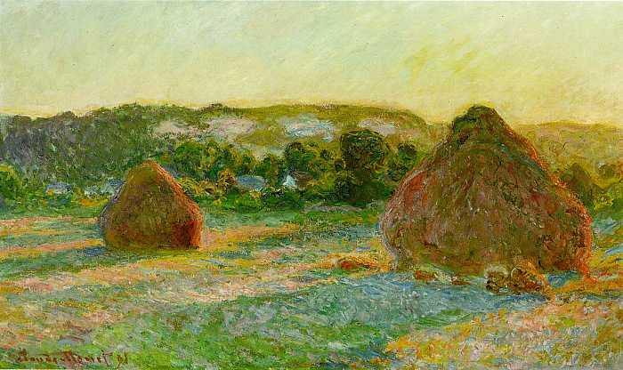
Figure 1: CLAUDE MONET. “Impressionism”. Artfactory.com, (1840-1926)

With time, the impressionist movement advanced above this detriment and famously became revered art movement in history. They greatly owe their popularity to ever plummeting affection of the public towards the vivacity in their technique.
The contributions of impressionism movement to modern art are widely adored. They own the credit to having incorporated photograph cropping in art. Through their composition technique, they continuously shunned conservative ideology. For instance, the shapes, colors, tones and lines of imageries created by traditional artists were arranged in a manner that the eye of the viewer was directed to the painting focal point. The latter which was at the midpoint position had for ages been deemed as the most vital area of a portrait. Thus, it was an outright poor composition to detract from the focal point the ends otherwise background of a painting. During this era, photography was in sophomore phases of creation. Since there often existed a diversity between what in actuality appeared on the negative and what the photographer had observed in the cameras’ viewfinder, to increase photograph composition, the photographers opted to crop their picture.⁵ The outcome for the latter move bulged in strange arrangements that accentuated forms and shapes on the image’s brink. Hence, the impressionists embraced the irregular effects of cropping and made it their composition’s conspicuous feature.
Similarly, the impressionists exclusively influenced the painting outside technique. Although a series of artists embraced the idea almost the same time as them, they are depicted as the first group to revive it. The introduction of paints in tubes partially served as a booster to them. The latter development enabled them to move around all artistry related gear in cases. Since the impressionists were dedicated to analyzing the effect of light on color in an environment, they found it a conviction and a necessity to carry out out-of-doors painting. Concerning this, rural areas, as well as urban landscapes, were adopted as their most prominent and natural themes. Hence, in the modern art arena, a depiction of such artwork is instantaneously linked to impressionism movement.
Successively, the impressionist movement played a bigger role in developing ideas associated with color. To come up with the reserve of ideas adopted in modern art, this group of artists was highly encouraged by the Japanese woodblock motifs with bold designs present in France during their time. The prints had disproportionate arrangements that juxtaposed enormous extents of regular color with blotches of sophisticated pattern, a concept that provided a compositional presentation. They held the view that even the most unconventional artists, prerequisite an assurance that their chosen path has some backgrounds in convention. Although from a dissimilar cultural upbringing, the impressionists obtained the intended instance of convention from the composition of Ukiyo-e masters which comprised of Hiroshige and Hokusai. Thus they got the confidence that became their thrust to explore new ideas of art.⁶
Similarly, the celebrated idea of figure and portraits composition with perceptible personages traversed from the impressionism group of artists. Impressionists Degas, Renoir alongside Lautrec were the first artists who painted among the first figures and pictures compositions. For instance, in France at At the Moulin Rounge one can easily find and behold a portrait composition that was immensely predisposed by cropping ideas in photography as well as the design and model of Japanese motifs. It is all the impressive efforts of impressionist Lautrec. The composition of this groundbreaking artwork by artist Lautrec included a self-picture beside his lanky cousin, Gabriel. The motif depicts them moving away from can-can cancer La Goulue who is portrayed to be busy setting her mane.⁷ On the same note, a group is settled in front of them which comprise of a detractor and author Dujard Edward, artistes La Maracona besides the bloodshot-headed Avril Jane, and Paul Sescau a professional photographer. At a glimpse, it is purported that it was the performer Mary Milton with emerald spotlight lit facade who was cropped by the picture’s brink. Moreover, in the art industry, the concept of painting and drawing items which are arrayed on top of a table such as blossoms, fruits and domiciliary objects underlines the concept of still life.⁸
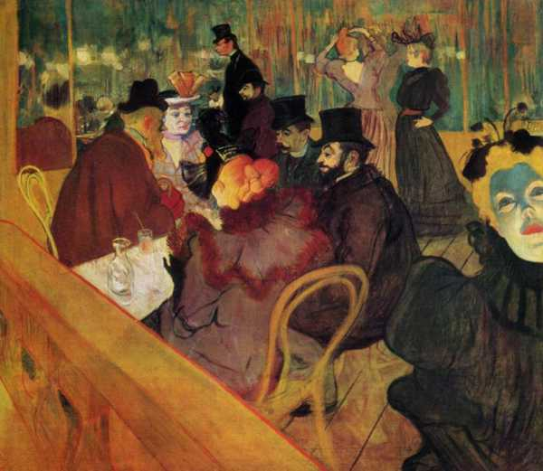
Figure 2: CLAUDE MONET. “Impressionism”. Artfactory.com, (1840-1926)
Artists opted to choose this concept over the past centuries based on several motives among them, still, life held a symbolic meaning which publicized a hidden idea or story; To reflect owner's status which could be either conceited or unpretentious; To capture the fleeting prettiness of a piece such as a drupe or a bloom; To exhibit accomplished painting method of an artist; And as a controlled structure to express the nonconcrete potentials of the painterly rudiments.
However, the impressionists rarely adopted and embraced still life concept on a wide extends. Primarily they portrayit as not being plain air theme that could be appropriate to capturing color and light distinctive makings. Nonetheless, there exist a handful of groundbreaking instances of impressionists' still life representations such as the Fruit of the Midi by Renoir. The Renoir's portray comprises of prudently designated vegetables and fruits to produce a prismatic color range that distances the impressionist gamut. Be it still life, landscape or painting of figures, the clique of impressionists artists always changed and distinguished the ordinary place, establishing glamor and exquisite in hazy harbors at daybreak, dignified the ordinary man labor strives, drew delight in the middle-class folks' time-out as well as portrayed vivacity in a dish of produce.
Consequently, in the standard of present-day art, the impressionism movement was first to be established. This firstborn of all movements has an undisputed reputation for having had an enormous impact on the development of twentieth-century art. As the fate of all avant-garde styles, impressionism was increasingly engrossed into the mainstream and its precincts turned out to be exasperating to the subsequent cohort. Although the likes of artist Georges Seurat and Paul Gauguin were immersed in impressionism traditions, they unceasingly pushed the restrictions of bravura through a diversity of ingenious angles. Thus, their efforts laid the groundwork of twentieth-century art. To recognize their efforts, they were branded as post-impressionists. However, this is a collective as well as a general term and the styles and impressionist impact they spearheaded have no commonality. For instance, expressionism movement was later led by Van Gogh and Divisionism and Fauvism by Seurat among others.
In short, impressionism, a name that finds its origin from a sardonic review in an ironic magazine, was a painting style that applied scientific scrutiny of color to capture the effects of light in an adulterated environment. Its paintings comprised of meagre strokes of untainted color which variegated the eye of the observer when observed from afar. The impressionists spearheaded the painting outside technique. Also, the technique they greatly valued was the landscape painting theme with fewer still lifes, figure compositions and painted representations.⁸ The impressionists were greatly influenced by the Japanese woodcuts as well as photography encroachments. In this regard, it is depicted as the first modern art movement with far-reaching influence and impact on the development of art in the twentieth century.
However, the impressionists rarely adopted and embraced still life concept on a wide extends. Primarily they portrayed it as not being plain air theme that could be appropriate to capturing color and light distinctive makings. Nonetheless, there exist a handful of groundbreaking instances of impressionists' still life representations such as the Fruit of the Midi by Renoir. The Renoir's portray comprises of prudently designated vegetables and fruits to produce a prismatic color range that distances the impressionist gamut. Be it still life, landscape or painting of figures, the clique of impressionists artists always changed and distinguished the ordinary place, establishing glamor and exquisite in hazy harbors at daybreak, dignified the ordinary man labor strives, drew delight in the middle-class folks' time-out as well as portrayed vivacity in a dish of produce.
Consequently, in the standard of present-day art, the impressionism movement was first to be established. This firstborn of all movements has an undisputed reputation for having had an enormous impact on the development of twentieth-century art. As the fate of all avant-garde styles, impressionism was increasingly engrossed into the mainstream and its precincts turned out to be exasperating to the subsequent cohort. Although the likes of artist Georges Seurat and Paul Gauguin were immersed in impressionism traditions, they unceasingly pushed the restrictions of bravura through a diversity of ingenious angles. Thus, their efforts laid the groundwork of twentieth-century art. To recognize their efforts, they were branded as post-impressionists. However, this is a collective as well as a general term and the styles and impressionist impact they spearheaded have no commonality. For instance, expressionism movement was later led by Van Gogh and Divisionism and Fauvism by Seurat among others.
In conclusion, impressionism, a name that finds its origin from a sardonic review in an ironic magazine, was a painting style that applied scientific scrutiny of color to capture the effects of light in an adulterated environment. Its paintings comprised of meagre strokes of untainted color which variegated the eye of the observer when observed from afar. The impressionists spearheaded the painting outside technique. Also, the technique they greatly valued was the landscape painting theme with fewer still lifes, figure compositions and painted representations. The impressionists were greatly influenced by the Japanese woodcuts as well as photography encroachments. In this regard, it is depicted as the first modern art movement with far-reaching influence and impact on the development of art in the twentieth century.

Bibliography
Chipp, Herschel Browning, and Peter Selz. Theories of modern art: a source book by artists and critics. Univ of California Press, 1968.
CLAUDE MONET. “Impressionism”. Artfactory.com, (1840-1926). https://artyfactory.com/art_appreciation/art_movements/impressionism.htm
Hauser, Arnold. The Social History of Art: Naturalism, impressionism, the film age. Vol. 4. Psychology Press, 1999.
Heller, Reinhold, and Henri de Toulouse-Lautrec. "Rediscovering Henri de Toulouse-Lautrec's" At the Moulin Rouge"." Art Institute of Chicago Museum Studies 12, no. 2 (1986): 115-135.
Icoglu, Oguz, Bilge Gunsel, and Sanem Sariel. "Classification and indexing of paintings based on art movements." In 2004 12th European Signal Processing Conference, pp. 749-752. IEEE, 2004.
Kaufmann, Thomas DaCosta. Arcimboldo: visual jokes, natural history, and still-life painting. University of Chicago Press, 2009.
Maki, Tomoko. "Connections Across Oceans: Debussy, Impressionism, and" The Floating World (Ukiyo-e)" of Japanese Art." PhD diss., 2014.
Nochlin, Linda. The body in pieces: the fragment as a metaphor of modernity. New York: Thames and Hudson, 1994.
Rubin, James Henry. Impressionism. Phaidon, 1999.

Chipp, Herschel Browning, and Peter Selz. Theories of modern art: a source book by artists and critics. Univ of California Press, 1968. ²Icoglu, Oguz, Bilge Gunsel, and Sanem Sariel. "Classification and indexing of paintings based on art movements." In 2004 12th European Signal Processing Conference, pp. 749-752. IEEE, 2004.
3Hauser, Arnold. The Social History of Art: Naturalism, impressionism, the film age. Vol. 4. Psychology Press, 1999. ⁴Rubin, James Henry. Impressionism. Phaidon, 1999.
5Nochlin, Linda. The body in pieces: the fragment as a metaphor of modernity. New York: Thames and Hudson, 1994. ⁶Maki, Tomoko. "Connections Across Oceans: Debussy, Impressionism, and" The Floating World (Ukiyo-e)" of Japanese Art." PhD diss., 2014.
7Heller, Reinhold, and Henri de Toulouse-Lautrec. "Rediscovering Henri de Toulouse-Lautrec's" At the Moulin Rouge"." Art Institute of Chicago Museum Studies 12, no. 2 (1986): 115-135. 8Kaufmann, Thomas DaCosta. Arcimboldo: visual jokes, natural history, and still-life painting. University of Chicago Press, 2009.
7Heller, Reinhold, and Henri de Toulouse-Lautrec. "Rediscovering Henri de Toulouse-Lautrec's" At the Moulin Rouge"." Art Institute of Chicago Museum Studies 12, no. 2 (1986): 115-135. 8Kaufmann, Thomas DaCosta. Arcimboldo: visual jokes, natural history, and still-life painting. University of Chicago Press, 2009.

